Working Script Snapshot
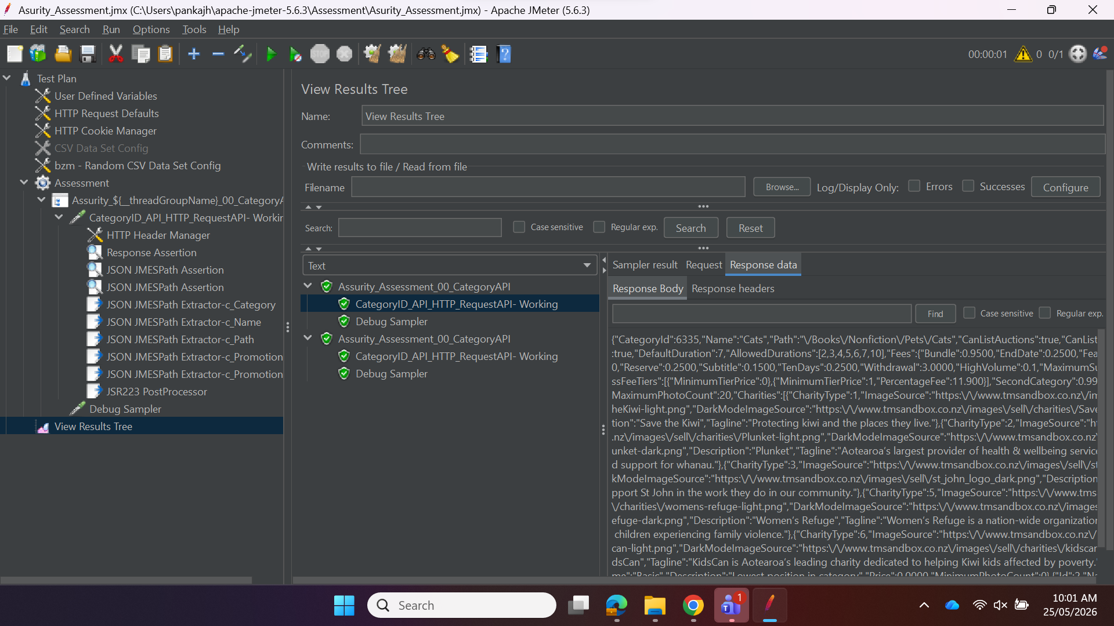
Jmx script, CSV file and Output file Snapshot
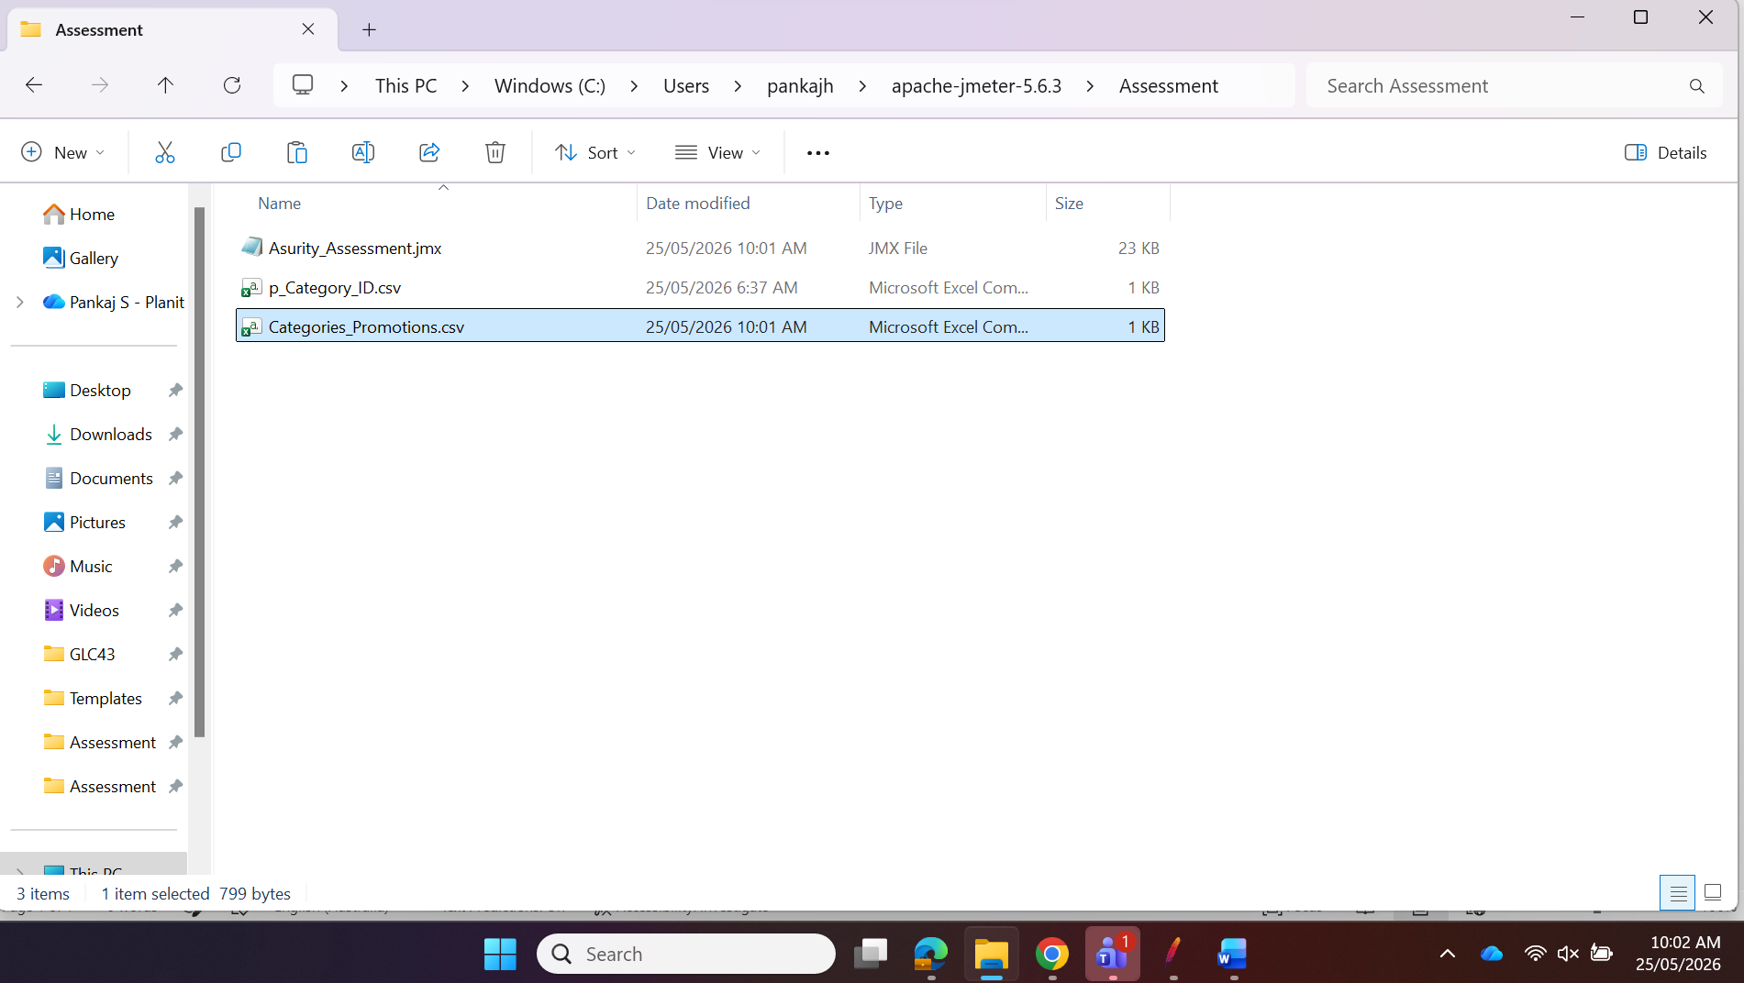

Output File Content Snapshot
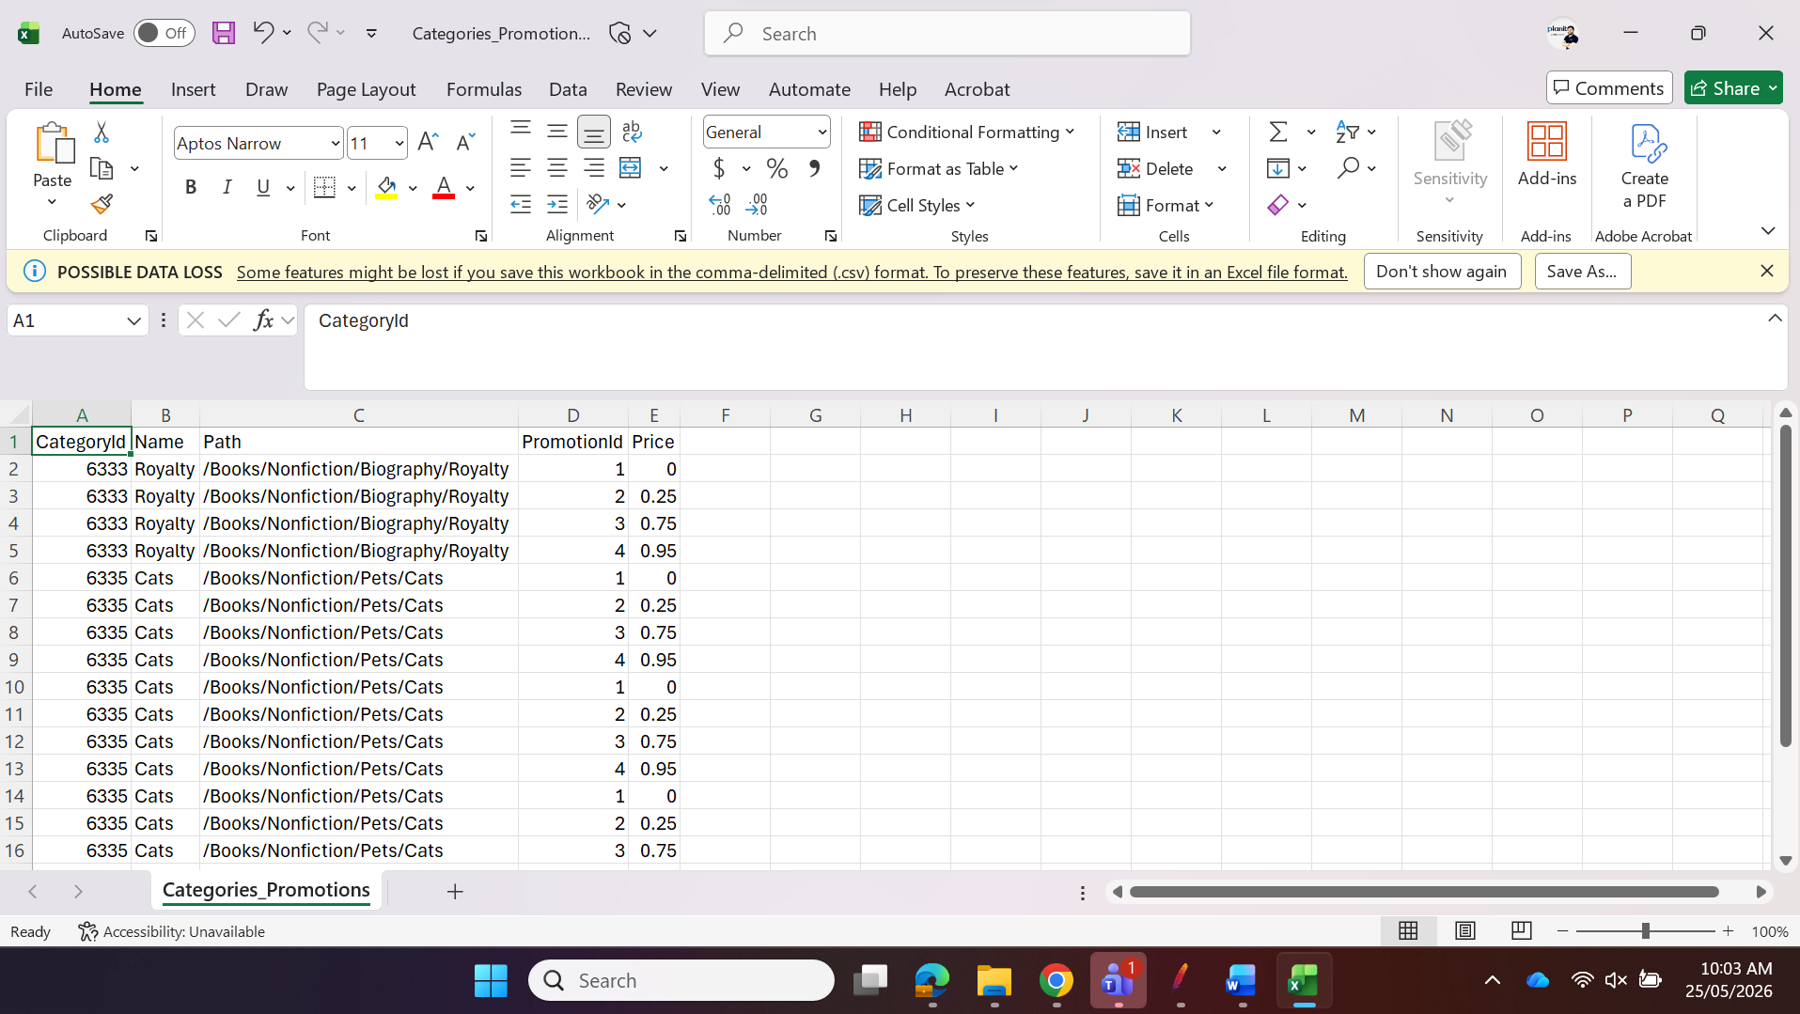

NFR # | Description
NFR-01 | Test should support Vusers (Threads) half the count of Category IDs shared in Test Data
NFR-02 | The test should ramp up at one VUser (Thread) per second
NFR-03 | Test should achieve 10 API calls in total for the 1-minute Steady State duration
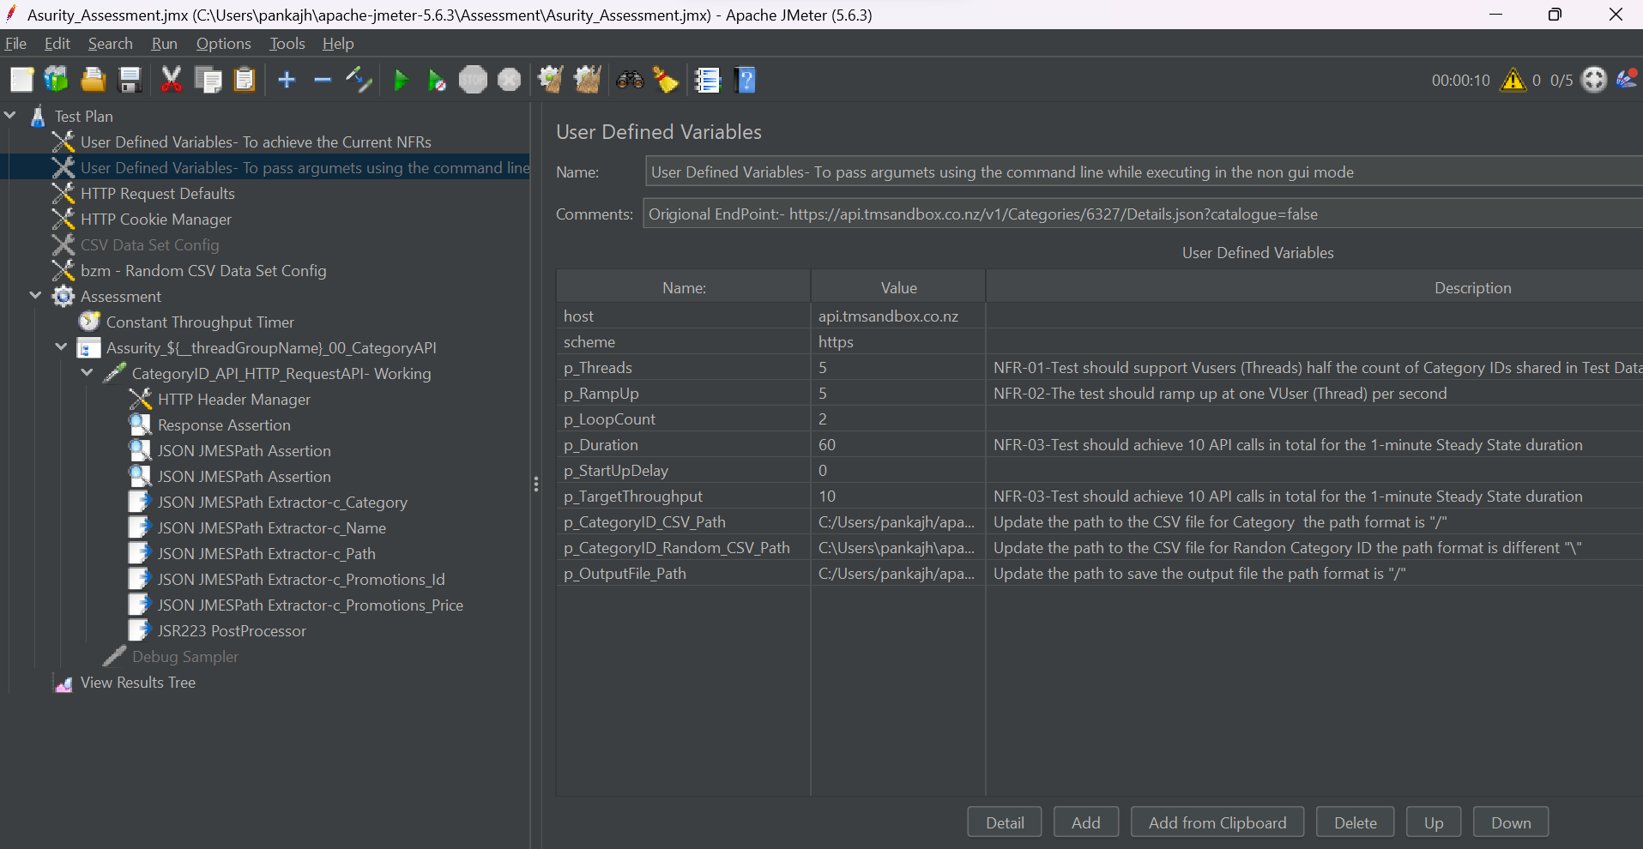

Achieved 10 API calls within a steady state duration of 1 min with a ramp up of 1 user per second.
